Perforated Duodenal Ulcer
Stem: A 58-year-old woman presents to the emergency department (ED) with a 1-hour history of generalized abdominal pain that began abruptly and now radiates to both shoulders. The patient has a prior history of peptic ulcer disease but is not currently on acid suppression therapy, and she is on oral steroids for a skin condition. No prior abdominal surgery. Does not smoke tobacco or drink alcohol.
ED physician calls you and tells you a CT Abdomen is ordered, vitals: Temperature is 36.5°C, heart rate is 100 bpm, blood pressure is 125/70 mm Hg, and her abdomen is diffusely tender to palpation, labs are processing. Any thing else you want to order?
- Upright chest x-ray or an abdominal x-ray.
You go to see the patient; X-ray technician just finished the xray you requested?

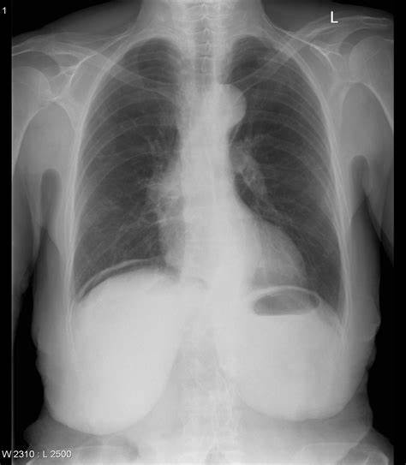

Transport is waiting to take the patient to CT, while you are blood pressure is 90/55 HR 126 RR 21.She is quite but uncomfortable appearing. What would you like to do ?
- Resuscitation: IVF, Antibiotics, Foley catheter, NG tube.
- OR for exploratory laparotomy.
On exploration, you identify a 1 cm anterior duodenal perforation. How would you address that?
Omental patch.
Patient recovers and get discharged, 18 months later she shows up in your clinic with GERD symptoms, despite being on PPIs, you decided to do EGD describe?
- Procedural sedation
- Place in left lateral decubitus position.
- Insert scope into mouth under direct visualization.
- Pass the scope past the cricoarytenoid cartilage into the esophagus.
- Ensuring direct visualization, pass the scope through the esophagus with continuous insufflation in order to visualize the entire esophagus.
- Visualize the gastroesophageal junction and pass into the stomach.

Scenario: Your patient is 52 Y M, prior history of PUD who tells you symptoms had been refractory, patient vitals are within normal range, when you proceed to OR you encounter only minimal contamination, would you consider anything different for this patient?
- Definitive ulcer procedure.
Describe one?
- Truncal vagotomy and pyloroplasty.
  - Isolate the distal esophagus.
  - Identify, dissect, and transect the vagal trunks—send nerve biopsy to pathology.
  - Dissect the distal 6-cm of the esophagus to ensure complete division of vagal fibers.
  - Mobilize the duodenum.
  - Make a longitudinal incision from the antrum onto the proximal duodenum.
  - Place stay sutures at either end of the incision to facilitate transverse closure.
- Antrectomy
  - Free the greater curvature of the stomach.
  - Dissect the first part of the duodenum from the pancreas.
  - Divide the stomach.
  - Ligate the right gastric artery at the level of the pylorus
  - Divide the duodenum just distal to the pylorus—send duodenal stump margin for pathology.
  - Complete with either a Billroth I or Billroth II anastomosis.
- Parietal Cell Vagotomy.
  - Divide the lesser omentum from the lesser curvature.
  - Encircle the trunks with Penrose drain and apply tension to facilitate exposure of branches.
  - Dissect and ligate neurovascular branches of the vagal trunks proximal to the crow’s foot of the nerve of Latarjet
  - Skeletonize the distal 6 cm of the esophagus to ensure complete division of criminal nerve of Grassi.

Infected Ventral Hernia Mesh
Stem: A 49-year-old female is seeking second opinion from you for a recurrent hernia. Her hernia repair history includes prior previous open repairs; using a permanent synthetic mesh. Her most recent repair 1 year prior to presentation involved open component separation with biologic mesh reinforcement.
She initially developed some purulent drainage from the wound, she tells you, it was cleaned by her surgeon in the office. However, since that time, she has had ongoing drainage from her wound and she didn’t follow up.
Past medical and surgical history: hypertension, Roux-en-Y gastric bypass, open colon surgery, and open appendectomy.
PE: 2 × 1-cm opening in the midportion of her abdomen with chronic granulation tissue and mild drainage. BMI of 27 kg/m2 and

What is your differential diagnosis and work up?
- Prosthetic mesh infection
- Persistent seroma
- Enterocutaneous fistula (ECF

- CT scan: Prosthetic mesh with significant inflammation and a small fluid collection, contrast seen through the bowel loop underneath the mesh but not extending into the inflammatory process.
- CBC, CMP normal labs
- Culture from her wound: MSSA.
What is your diagnosis and what will you offer to and counsel the patient?
- Most likely Diagnosis is chronic infected mesh.
- Given failed conservative management, I will offer surgical mesh excision.
- Informed consent for – Removal of infected mesh, address any underlying GI tract issues.
- Counsel patient hat once mesh is removed, hernia is at high risk of recurrence. May need biological mesh to facilitate closure.
- Interval definitive abdominal wall hernia repair afterwards.
Describe the operation?
- Laparotomy in the area of infected mesh.
- Complete adhesiolysis and evaluation of bowel and surrounding structures
- Repair any gastrointestinal issues as appropriate.
- Excision of all prosthetic mesh taking care to preserve abdominal wall muscles.
- Utilize landmarks such as transfascial sutures or tacks to identify periphery of the mesh.
- Repair the resulting hernia defect with primary closure versus resorbable mesh.
Examiner: In this scenario, the patient had several pieces of infected mesh as a result of her multiple previous hernia repairs. After adhesiolysis, there was no evidence of gastrointestinal involvement. All of the mesh was able to be completely removed, and the resulting hernia defect was repaired with slowly resorbable suture.
Scenario: This patient developed a recurrent hernia 9 months after surgery, she comes back to you to consider repair. Ct scan shows wide midline gap > 20 cm. , what will you offer the patient?
- Component Separation.
Describe the surgery?
- Perform complete adhesiolysis of the entire anterior abdominal wall to the paracolic gutters to allow muscular components to slide to the midline during reconstruction.
- Elevate lipocutaneous flaps 2 cm lateral to the linea semilunaris, edge of the rectus muscle.
- Incise the external oblique fascia and separate the external and internal oblique muscles in their avascular plane.
- Continue the dissection 3–4 cm above the costal margin and inferiorly to the inguinal ligament.
- Release the posterior rectus sheath by making an incision 1 cm lateral to the linea alba.
- Develop the retromuscular plane out to the linea semilunaris while preserving the neurovascular bundles to the rectus muscle.
- Place an appropriately sized biologic graft or mesh as an underlay.
- Drains placed over the mesh.
- Remove excess devascularized skin,
- Close over multiple drains.

Volvulus.
Stem: ER calls you to see an 83-year-old male presenting with severe, persistent upper abdominal pain, and multiple episodes of emesis over the past 48hr. He has dementia and lives in a nursing facility, so history is difficult to obtain.
Vitals : Tachycardic at 105, normotensive, afebrile.
Exam: His abdomen is distended and TTP in the LLQ but without guarding or rigidity.
Labs: WBC 12k, lactic of 2.0.
KUB is obtained, interpreted as “Grossly dilated colon. No evidence of pneumoperitoneum”

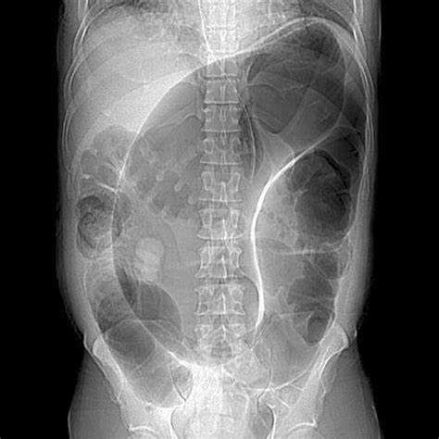

What is your differential diagnosis?
- Sigmoid Volvulus.
- Large bowel obstruction
- Cancer.
- IBD.
- Pseudo obstruction
What would you do for this patient, what is your work up diagnosis and management?
- Resuscitation
- Sigmoidoscopy for decompression (Resident must say they will do it themselves, not consult GI)
Additional Workup or Studies:
1. Family history of malignancy; Last colonoscopy
2. CT abdomen / pelvis with IV contrast → demonstrates sigmoid volvulus
What would you like to do now?
1. Two large bore IV’s, resuscitate the patient, +/- wound ostomy consult for stoma marking
2. Before proceeding to the operating room, are there any additional therapies that can be attempted or discussed?
a. non-operative decompression; would you be doing the flex sig?
You successfully detorse the patient and he begins feeling better. Now what?
- - Admit.
- - Bowel prep.
- - Ostomy marking.
- - Plan with Sigmoidectomy (Due to risk of recurrence)
  - All approaches acceptable, resident need to describe (open, lap , robotic .. primary anastomosis +/- diversion versus end colostomy.
Scenario: This same patient arrives and is diffusely TTP with evidence of guarding. He is febrile to 102 and has leukocytosis to 17k. What would you do differently?
1. proceed directly to OR for Sigmoidectomy.
Scenario: The patient from before that we just took to the operating room for the Hartmann’s; he is now POD3. You are called to the bedside by the wound ostomy nurse and with concerns about the appearance of the ostomy. She says the “Ostomy is dusky in appearance with patchy areas of blackness” How do you proceed?
1. Insert test tube or flexible scope to assess if necrosis descends below the level of the fascia
2. if the necrotic tissue does descend below the level of the fascia? → Patient needs a revision of their ostomy in the operating room, otherwise observe.
Scenario: This patient is a 58-year-old female with hx of HTN, HLD, 5 vaginal deliveries presenting with acute abdominal pain, and KUB demonstrating a distended air-filled cecum within the central abdomen. What is your approach to this patient?
1. Operative; no role for non-operative management or endoscopic.

